Assignment 2 - Dimensionality Reduction (PCA and SVD)

Dimensionality reduction on a dataset using PCA and SVD.

Gaurav H Sangappa : PES1201700282

Pranav Kelkar : PES1201700174

Ananya Nair :PES1201700146

Abhilash Balaji :PES1201700041

PCA

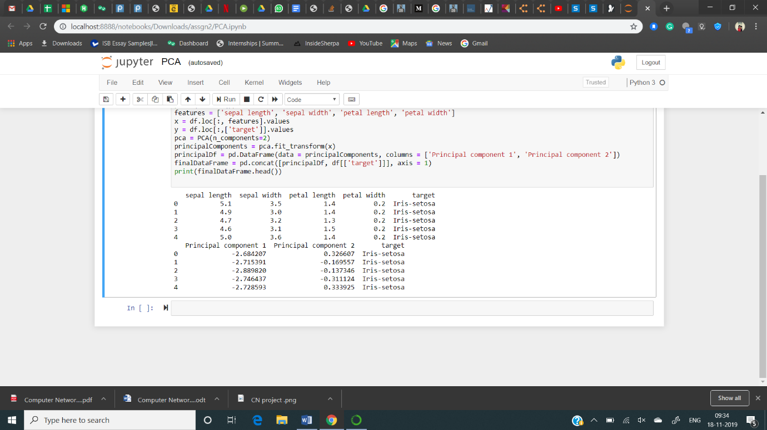

SVD

